EE3060 Probability – Proposed questions and answers

Group 4

Question 1:

Suppose that in a community of 400 people,300 bike or swim or do both, 160 swim, and 120 swim and bike. What is the probability that an adult, selected at random from this community, bikes?

Answer 1:

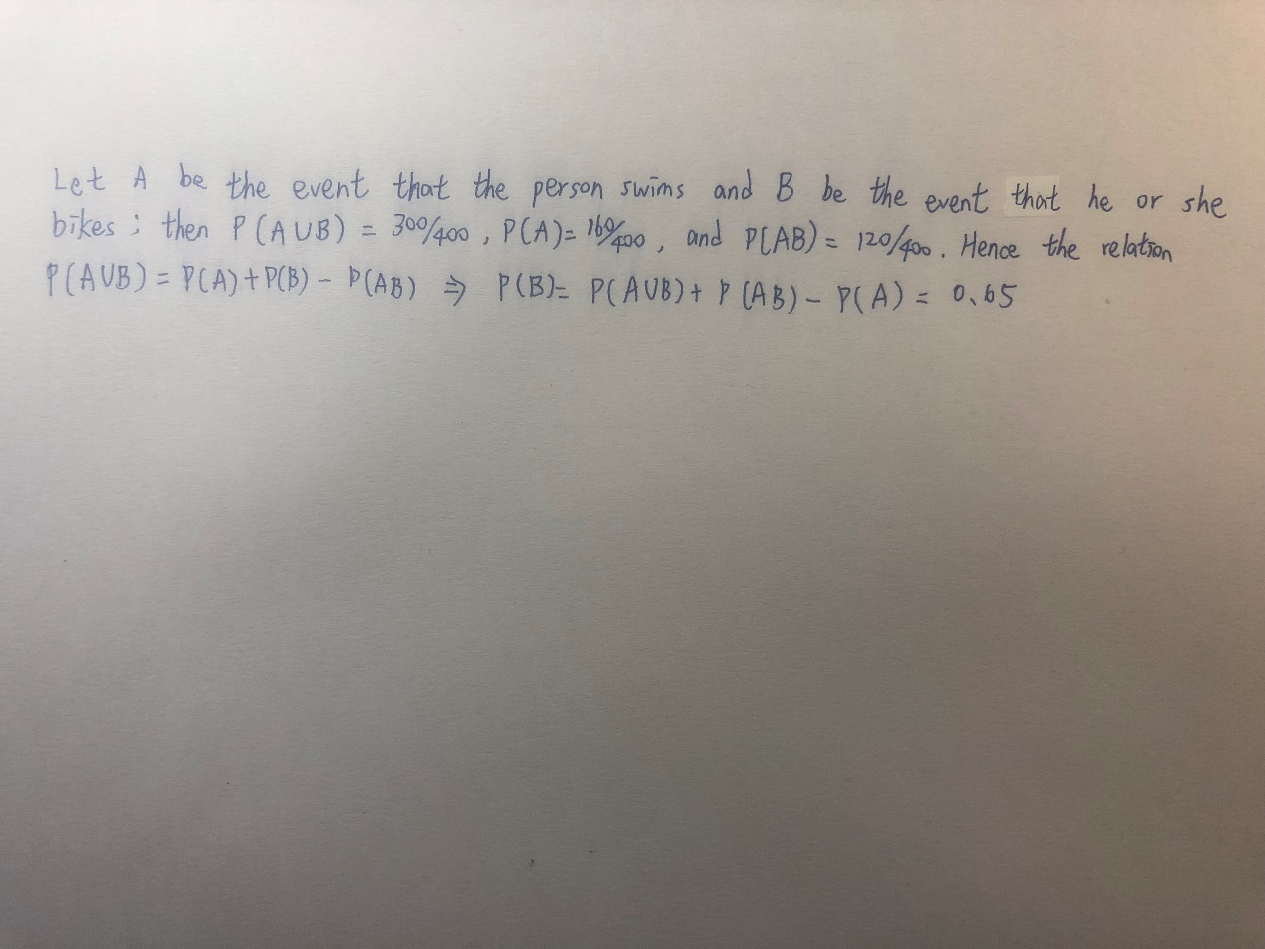

Question 2:

There is a King want to kill a prisoner. Since he want to show that he is a kind, generous King, he don’t execute death sentence directly. The King set up 4 doors, only one can escape. After the prisoner has chosen a door, he bribes a guard, hope to know which door can escape. But the guard only tell him one of the remaining doors which can’t escape. What is the probability the prisoner can escape if he switch to the other door?

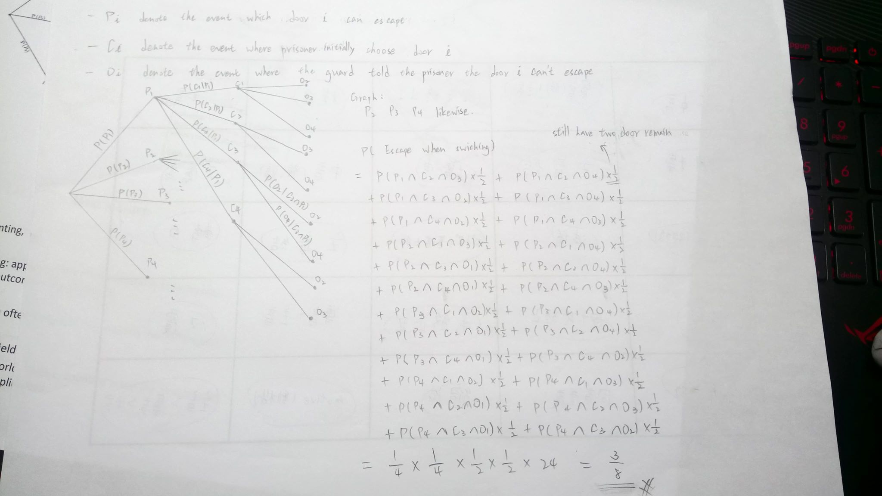Answer 2:

Question 3:

Sally is a reckless girl who like to wear high heels everyday. She have three different type of heels, and the probability for her to choose for each heels are 20% for invisible heels, 30% for flying heels, and 50% for smart heels. However, due to her recklessness, everytime she choose to wear certain heels, she may fall. The possibility for her to fall in invisible heels are 60%, 10%for flying heels, and 30% for smart heels. Question: Sally fall today, what is the possibility that she wear smart heels?

Answer 3:

$$P\left(A | B\right)= \frac{P(A∩B)}{P(B)}$$

P(B) is the total possibility for Sally to fall a day. P(A) is the possibility that Sally wears smart heels. Therefore,

$$P\left(A | B\right)=\frac{(0.5*0.3)}{(0.2*0.6+0.3*0.1+0.5*0.3)}=1/2$$

Question 4:

There are three boxes, one of which contains a prize. A contestant is given two chances, such that if he chooses the wrong box in the first round, that box is removed from the selection and he then chooses between the two remaining boxes.  
1. What is the probability that the contestant wins?  
2. Does the contestant’s probability of winning increases on the second round? If yes ,what’s the probability?

Answer 4:

1. case 1: if the contestant guesses the right box

p(w1) = 1/3

case 2: if the contestant guesses the wrong box

p(w2) = 2/3 \* 1/2 = 1/3

from case1 and 2, we know that the probability that the contestant wins is p(w1) + p(w2) = 2/3

2. Yes, the probability increases as its a 50% chance to win as 1 wrong box is eliminated.

Question 5:

The tournament of 1-on-1 badminton is coming and you are going to attend it. There are 12 players you have to play with. The probability of winning 8 players (type 1) in the 12 players is 90% since you are good at badminton. However, there are 2 players (type 2) are better than you, that makes the winning probability 40%. There are 2 players (type 3) left and you don’t know them, which makes the winning probability 50%. Unfortunately you caught a flu today and the winning rate against the type 2 and 3 player should have a 70% discount. What’s the rate of being the champion.

Answer 5:

2/3\*0.9+1/6\*0.4\*0.7+1/6\*0.5\*0.7=0.705 approximately 70%